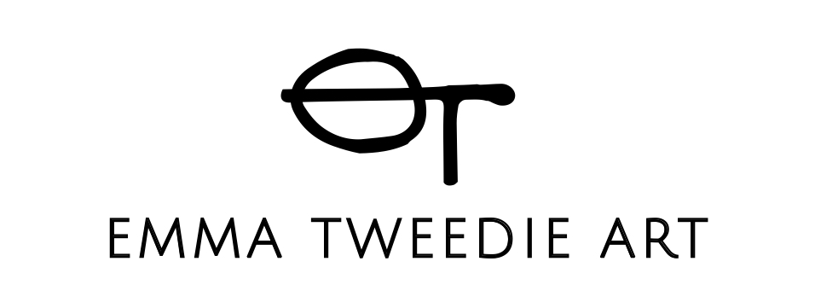

GDPR : PRIVACY POLICY

Emma Tweedie Art ("We") are committed to protecting and respecting your privacy. This policy (together with our terms of use and any other documents referred to on it) sets out the basis on which any personal data we collect from you, or that you provide to us, will be processed by us.

Please read the following carefully to understand our views and practices regarding your personal data and how we will treat it. For the purpose of the General Data Protection Regulation 2018(the Act),

the data controller is Emma Tweedie Art (a company registered in England trading as Teacake Tuesday Ltd 06996179) whose registered office is at Studio 17, Fusion Arts, 53 Eden Street, KT1 1BW.

Information we collect from you

We collect and process the following data about you:

- Information that you provide by filling in forms on our websites - LOCATED at www.emmatweedie.art.
- This includes information provided at the time of registering to use our sites, subscribing to our services, posting material or requesting further information or services. We also ask you for information at other times, for example when you report a problem with our site.

- If you contact us, we keep a record of that correspondence in order to fulfil our contractual or legal obligations to you.

- We may also ask you to complete a pop up form that we use for marketing purposes, although you do obliged to do so in order to be able to use the site and its functions.

- Details of transactions you carry out through our sites and of the fulfilment of your bookings and orders for contractual and legal obligation.

- Details of your visits to our sites including, traffic data, location data, weblogs and other communication data, for legitimate interest and contractual obligation.

- All tracking data is stored for a maximum of 5 years and for our legal obligation financial information is stored for 7 years.

./2

IP addresses and cookies

Our sites use cookies to distinguish you from other users of our sites. This helps us to provide you with a good experience when you use our sites and also allows us to improve our sites. By continuing to use our sites, you are agreeing to our use of cookies to enable us to fulfil our contractual obligations.

A cookie is a small file of letters and numbers that we store on your browser or the hard drive of your device if you agree. Cookies contain information that is transferred to your device’s hard drive.

We use functionality cookies to maintain a user's login state, which are necessary for the operation of the site.

We use tracking cookies to recognise you when you return to our sites, if you have selected the “remember me” option. This enables us to personalise our content for you, greet you by name and remember your preferences (for example, your choice of language or region).

You may refuse to accept these cookies by activating the setting on your browser, which allows you to refuse the setting of cookies.

However, if you select this setting you may be unable to access certain parts of our site. Unless you have adjusted your browser setting so that it will refuse cookies, our system will issue cookies when you log on to our sites.

We also use Google Analytics software to collect information about how you use our site. We do this to help make sure ours site is meeting the needs of our users and to help us make improvements.

Google Analytics stores information about

- The pages you visit and how long you spend on each page
- How you got onto our site
- What you click on when you are visiting our site
- Your name and address are not collected or stored as part of this
process and we don’t allow google to use or share our analytics data
- You can opt out of google analytics cookies by adjusting your browser settings

/3

Where we store your personal data

Sometimes we will need to share your personal data with third parties and suppliers outside the European Economic Area (EEA).

Protecting your data outside the EEA

The EEA includes all EU Member countries as well as Iceland, Liechtenstein and Norway.

We may transfer personal data that we collect from you to third-party data processors in countries that are outside the EEA such as Australia or the USA.

For example, this might be required in order to fulfil your order, process your payment details or provide support services.

If we do this, we have procedures in place to ensure your data receives the same protection as if it were being processed inside the EEA.

For example, our contracts with third parties stipulate the standards they must follow at all times. If you wish for more information about these contracts please contact our Data Protection Officer.

Any transfer of your personal data will follow applicable laws and we will treat the information under the guiding principles of this Privacy Policy Notice.

Uses made of the information

We use information held about you in the following ways:

- To ensure that content from the site is presented in the most effective manner for you and for your computer.
- To provide you with information, products or services that you request from us, or which we feel may interest you, or where you have consented to be contacted for such purposes.
- To carry out our obligations arising from any contracts entered into between you and us.
- To allow you to participate in interactive features of our service when you choose to do so To notify you about the changes to any of our services.

/4

Disclosure of your information

We may disclose your personal information to any member of our group, which means our subsidiaries, our ultimate holding company and its subsidiaries, as defined in section 1159 of the UK Companies Act 2006.

We may disclose your personal information
to third parties:

- In the event that we sell or buy any business or assets, in which case we may disclose your personal data to the prospective seller or buyer of such business or assets.

- If EmmaTweedieArt or substantially all of its assets are acquired by a third party, in which case personal data held by it about its customers will be one of the transferred assets.

- If we are under a duty to disclose or share your personal data in order to comply with any legal obligation, or in order to enforce or apply our terms of use [or terms and conditions of membership] and other agreements; or to protect the rights, property, or safety of EmmaTweedieArt, its customers or others.

An overview of your different rights:

You have the right to request:

- Access to the personal data we hold about you, free of charge in most cases.
- The correction of your personal data when incorrect, out of date or incomplete.
- That we stop using your personal data for direct marketing (either
- through specific channels, or all channels).
- That we stop any consent-based processing of your personal data after you withdraw that consent.
- Review by a Partner of any decision made based solely on automatic processing of your data (i.e. where no human has yet reviewed the outcome and criteria for the decision).

You can contact us to request to exercise these rights at any time as follows: info@emmatweedie.art
To ask for your information please contact The Data Protection Officer, Emma Tweedie.

If we choose not to action your request we will explain to you the reasons for our refusal.

/5

Your right to withdraw consent

Whenever you have given us your consent to use your personal data, you have the right to change your mind at any time and withdraw that consent.

Where we rely on our legitimate interest

In cases where we are processing your personal data on the basis of our legitimate interest, you can ask us to stop for reasons connected to your individual situation. We must then do so unless we believe that we have a legitimate overriding reason to continue processing your personal data.

Direct marketing

We have the right to stop the use of your personal data for direct marketing activity through all channels, or selected channels. We must always comply with your request.

Checking your identity

To protect the confidentiality of your information, we will ask you to verify your identity before proceeding with any request you make under this Privacy Notice.

If you have authorised a third party to submit a request on your behalf, we will ask them to prove they have your permission to act.

Changes to our privacy policy

Any changes we may make to our privacy policy on the future will be posted on this page and where appropriate, notified to you by email.

Contact

For any questions, queries or comments regarding our privacy policy, these should be addressed to: info@emmatweedie.art

